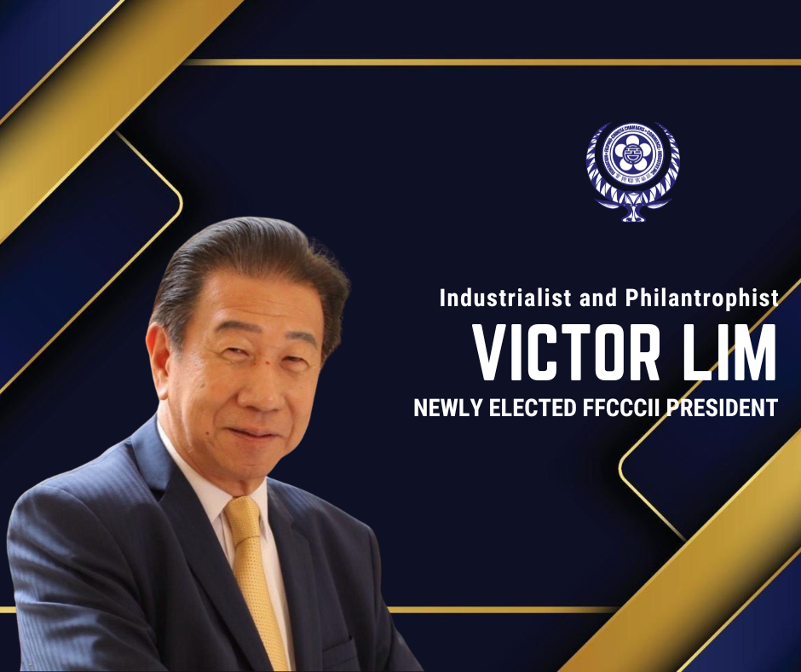

NEWS RELEASE

April 6, 2025

**INDUSTRIALIST VICTOR LIM ELECTED AS NEW PRESIDENT OF FFCCCII**

After Biennial National Convention and Rigorous Elections Supervised by SGV Group, FFCCCII Chooses Seasoned Leader to Spearhead Business and Civic Initiatives

MANILA, PHILIPPINES – The Federation of Filipino Chinese Chambers of Commerce and Industry, Inc. (FFCCCII) today April 6, 2025 announced the election of industrialist and philanthropist **Victor Lim** as its new President following a three-day biennial national convention and three rounds of voting by 800 delegates representing 170 Filipino Chinese business chambers and organizations. The convention was held at SMX Convention Center in Pasay City.

Lim succeeds outgoing President Dr. Cecilio K. Pedro, who led FFCCCII’s post-pandemic recovery and digitalization initiatives from 2023-2025. The transition marks a new chapter for the 71-year-old federation, the Philippines’ largest coalition of Filipino Chinese entrepreneurs and philanthropists. Aside from progressive business and economic advocacies, FFCCCII spearheads numerous socio-civic and cultural charities.

Also elected as the new FFCCCII Executive Vice-President is industrialist and real estate businessman Jeffrey Ng. Business and civic leader Dr. Lucio K. Tan is FFCCCII Chairman Emeritus.

A PROVEN LEADER WITH DEEP ROOTS

**Victor Lim** brings four decades of executive experience across manufacturing, trade, and education advocacy:

* President/CEO of VECO Paper Corporation and Everwealth Traders and Development Corporation
* Former EVP of FFCCCII and past leader of multiple industry groups:
* President: Philippine Stationeries Association, Alliance of Paper Traders Association, Philippine School Pads and Notebooks Manufacturers Association
* Adviser: Philippine Paper Industry Council
* Education Advocate:
* Vice President, St. Stephen’s High School Board of Trustees
* Past President, St. Stephen’s High School Alumni Association
* Community Bridge-Builder:
* Former leader of the Grand Family Association and Philippine Sejo Lim Family Association

A graduate of University of Santo Tomas (BS Chemical Engineering) and St. Stephen’s High School, Victor Lim embodies FFCCCII’s motto: “Business Excellence with Social Responsibility.” He is also first cousin of the late FFCCCII President Dr. Henry Lim Bon Liong of the Sterling Paper Group.

**FFCCCII: 71 YEARS OF NATION-BUILDING**

Among the causes of FFCCCII include:

* business and economic advocacies
* Donating over 6,400 rural public school buildings nationwide under its "Operation Barrio Schools"
* Mobilized donations of relief goods for disaster relief throughout the Philippines
* Conducts 88 free medical and dental missions yearly for urban poor communities
* Supports Filipino Chinese volunteer fire brigades across the Philippines